Code:
Skill 6 Task-1

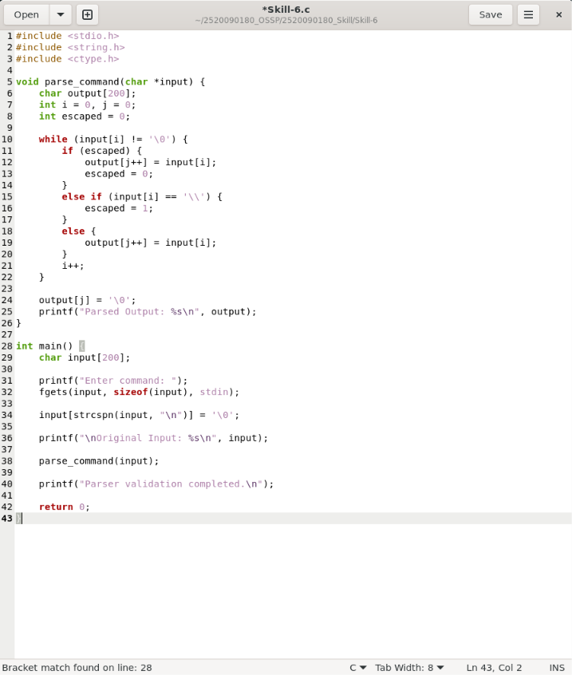

Output:

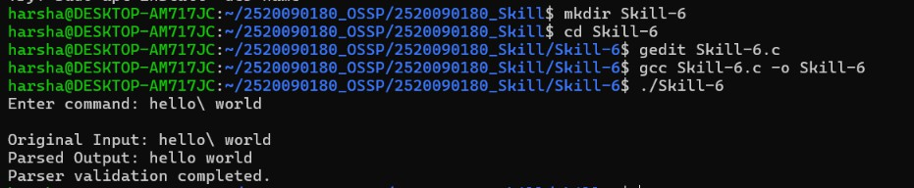
Task-2
Code:
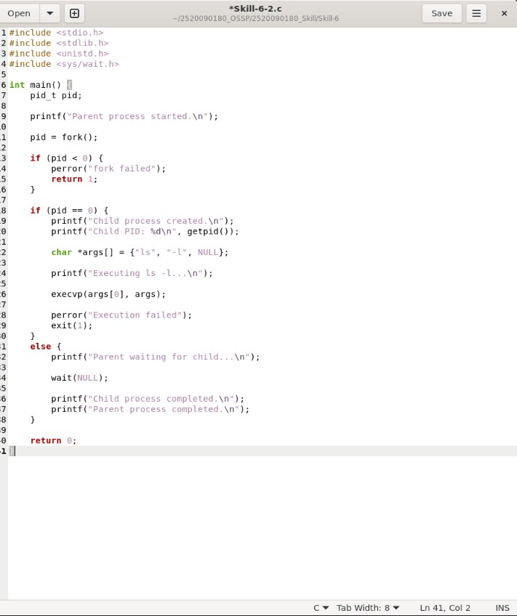

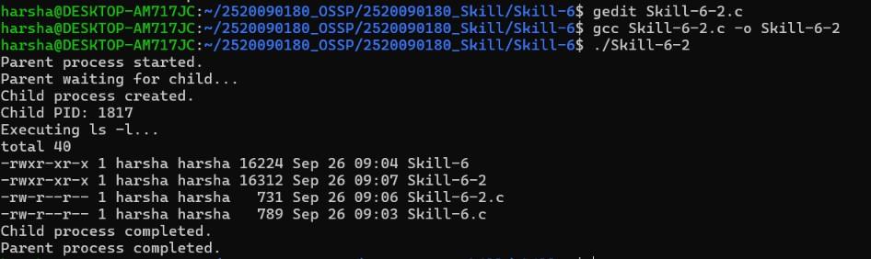
Output:

